# How to Install Jenkins on CentOS 7

Jenkins is a popular open source CI (Continuous Integration) tool which is widely used for project development, deployment, and automation.

This article will guide you through the process of installing Jenkins on a CentOS 7 server instance. In order to facilitate visitors' access, Nginx will also be installed as the reverse proxy for Jenkins.

Prerequisites

Before proceeding, you must have:

* Deployed a CentOS 7 server instance from scratch.
* Logged into your machine as a non-root user with sudo privileges.

Step 1: Update your CentOS 7 system

One of the Linux system administrator's best practices is keeping a system up to date. Install the latest stable packages, then reboot.

sudo yum install epel-release

sudo yum update

sudo reboot

When the reboot finishes, login with the same sudo user.

Step 2: Install Java

Before you can install Jenkins, you need to setup a Java virtual machine on your system. Here, let's install the latest OpenJDK Runtime Environment 1.8.0 using YUM:

sudo yum install java-1.8.0-openjdk.x86_64 -y

After the installation, you can confirm it by running the following command:

java -version

This command will tell you about the Java runtime environment that you have installed:

*openjdk version "1.8.0_91"*

*OpenJDK Runtime Environment (build 1.8.0_91-b14)*

*OpenJDK 64-Bit Server VM (build 25.91-b14, mixed mode)*

In order to help Java-based applications locate the Java virtual machine properly, you need to set two environment variables: "JAVA_HOME" and "JRE_HOME".

sudo cp /etc/profile /etc/profile_backup

echo 'export JAVA_HOME=/usr/lib/jvm/jre-1.8.0-openjdk' | sudo tee -a /etc/profile

echo 'export JRE_HOME=/usr/lib/jvm/jre' | sudo tee -a /etc/profile source /etc/profile

Finally, you can print them for review:

echo $JAVA_HOME

echo $JRE_HOME

Step 3: Install Jenkins

Use the official YUM repo to install the latest stable version of Jenkins, which is 1.651.2 at the time of writing:

cd ~

sudo yum install wget -- **Install the software wget**

sudo wget -O /etc/yum.repos.d/jenkins.repo https://pkg.jenkins.io/redhat-stable/jenkins.repo

sudo rpm --import https://pkg.jenkins.io/redhat-stable/jenkins.io.key

sudo yum install jenkins

Start the Jenkins service and set it to run at boot time:

sudo systemctl start jenkins.service

sudo systemctl enable jenkins.service

In order to allow visitors access to Jenkins, you need to allow inbound traffic on port 8080:

sudo firewall-cmd --zone=public --permanent --add-port=8080/tcp

sudo firewall-cmd –reload

**Note: -- If you are running Jenkins on AWS EC2 instance, then the above firewall configuration is not required. But make sure the firewall port is configured on Security Groups.**

Now, test Jenkins by visiting the following address from your web browser:

http://<your-server-IP>:8080

If the page does not come up, try to disable the SELINUX.

Edit the selinux config file

# **vi /etc/selinux/config**

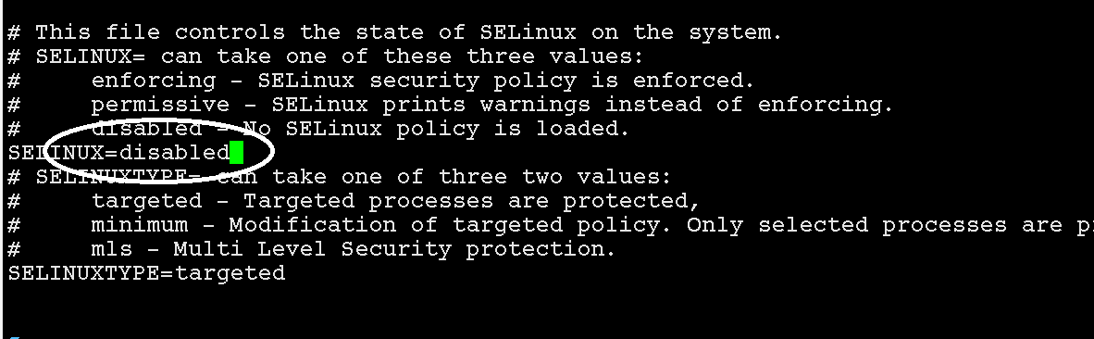

save the file -> press 'esc' and type ":wq" and enter.

REBOOT the linux machine and

$ **reboot or init 0**

Then try to access the jenkins web page.

http://<your-server-IP>:8080